Catering At Trinity
We are happy to accommodate particular dietary requirements; please specify when booking.

Menu
Cooked Breakfast - £5 per head - Sausage, bacon, egg, tomato, soda & potato bread, all served with toast & marmalade, tea & coffee.
Morning/Afternoon Tea - £4 per head - A selection of scones served with jam and cream, shortbread biscuits & a traybake selection with tea & coffee.

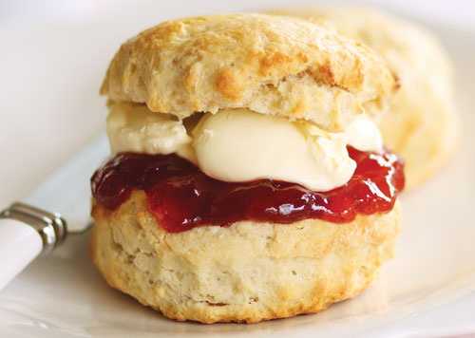

Lunches:
Sandwich Lunch - £5 per head - A selection of homemade sandwiches and traybakes served with tea & coffee.
Soup & Sandwich Lunch - £6.50 per head - Your choice of delicious homemade soup served with a selection of sandwiches, traybakes served with tea & coffee.
Supper - £7 per head - A selection of homemade sandwiches, cocktail sausages, vol-au-vents, shortbread and traybakes served with tea & coffee.

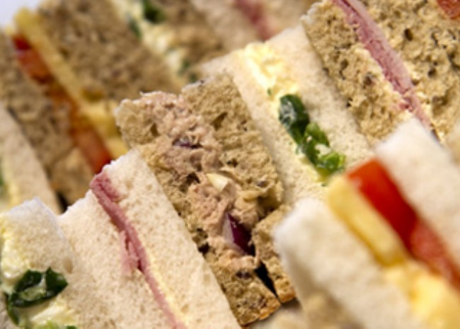

Fork Buffet (Self-Service) - £10 per head:
Choice of 2 dishes with side salad selection, wheaten & crusty breads; Quiche/Lasagne/Pie/Pasta Bake/Chilli/Curry/Sweet & Sour With Rice.
Choice of 2 desserts; Pavlova/Apple Tart/Cheesecake/Chocolate Roulade/Fresh Fruit Salad. All served with shortbread, tea & coffee.
Salad - £10 per head - Turkey & ham salad with a selection of side salads & wheaten bread.
Choice of 2 desserts; Pavlova/Apple Tart/Cheesecake/Chocolate Roulade/Fresh Fruit Salad. All served with shortbread, tea & coffee.
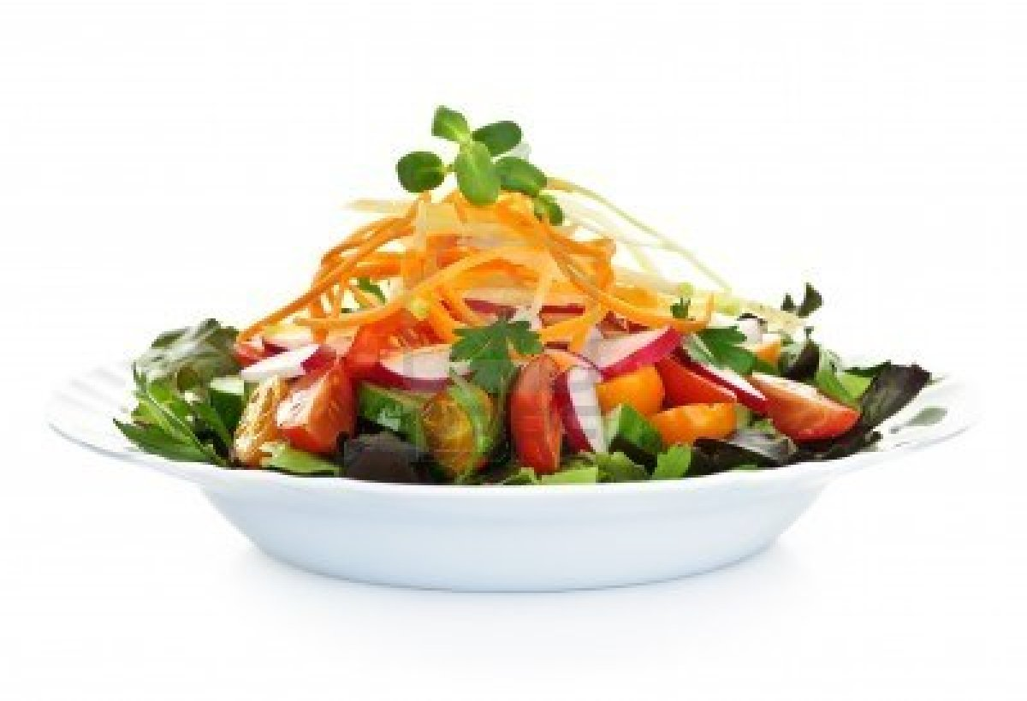

Dinner - 3 Course £13 per head & 4 Course £15 per head
- Soup & wheaten/Florida Cocktail/Melon
- Roast Beef/Chicken served with roast & creamed potatoes, 2 seasonal vegetables & juice provided on table
- Choice of 2 desserts; Pavlova/Apple Tart/Cheesecake/Chocolate Roulade/Fresh Fruit Salad.
- Tea, coffee and shortbread.

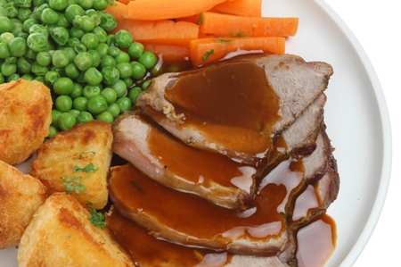

For further information or to make a booking please contact Christine 07800937857 or ccairnduff46@gmail.com

All Donations In Aid Of Trinity Presbyterian Building For The Future Fund

